Mr. Brea Stanley is a famous dress designer. He wants to run a dress shop independently and he needs a program to support the cashier. Therefore, he asks you as a programmer to make a program using the queue concept. Here are the descriptions of the program:

Program consists of 4 menus:

1. View Queue
2. Add Customer to Queue
3. Serve Customer
4. Exit

If user chooses View Queue, show the queue view that contains No, Customer’s Name, Dress Name, and Price.

If user chooses Add Customer to Queue, then:

* Ask user to input customer‟s name. It must be in alphabets only and the length must be between 3 and 20 characters.
* Ask user to input dress name. The length must be between 3 and 20 characters.
* Ask user to input dress price. The dress price must be between $50 and $999.
* Maximum customer in the queue is 10. If it has reached 10 customers, then show the message “--- Maximum Customer in a Queue is 10 ---” If not, then show the message “--- Success to Add Customer into Queue List ---”

If user chooses Serve Customer, then:

* Program will delete the data using the queue concept.
* If there is no data in the list, then show the message “--- There is No Customer in Queue ---”.
* If data has been successfully deleted, then show the message “--- [customer’s name] Has Been Served ---”

If user chooses Exit, then delete all data in the linked list and program will ends.

**Print Screen of Main Menu**

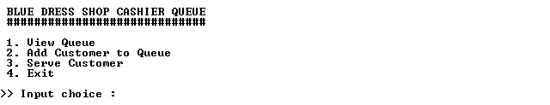

**Print Screen of View Queue Menu (Menu 1)**

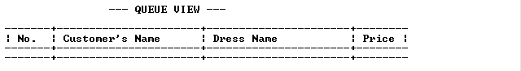

**Print Screen of Add Customer to Queue Menu (Menu 1)**

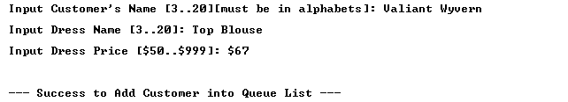

**Print Screen of View Queue Menu after Add Customer**

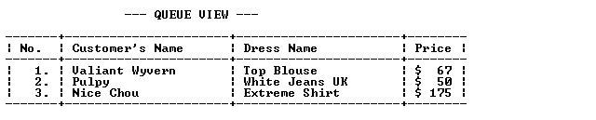

**Print Screen of Serve Customer Menu (Menu 3)**



**Print Screen of View Queue Menu (Menu 1) After Choosing Serve Customer Menu**

